Northeastern University
Mechanical and Industrial Engineering Department IE 6200: Engineering Probability and Statistics
Prof. Rehab Ali Section 02 - Fall 2024

ANALYZING SALES PATTERN OF SUPERSTORE
Final Report


Group 2

Advait Jigarbhai Naik Ajinkya Vitthalrao Jadhav Bhumika Channakeshava Rushil Vijayan
Saloni Vivek Tanpure Shivendra Chandrashekhar Jagtap

1.Problem Statement

Businesses often struggle to understand and respond to fluctuations in customer demand. Historical sales data can provide valuable insights into patterns such as seasonal peaks and yearly sales trends, which are essential for effective resource planning. However, without a structured analysis of these data patterns, businesses may face operational inefficiencies, such as over-allocation of resources during low-demand periods or under-preparation during peak times.

Thus, the team has conducted a descriptive analysis of historical sales data, focusing on recurring demand patterns across regions, product categories, and yearly sales cycles. The analysis will include hypothesis testing to explore significant differences in sales based on regional, categorical, and yearly sales variations. By uncovering trends, such as increased demand during holiday seasons or predictable monthly cycles, businesses will gain insights to align resources effectively, improve operational efficiency, and better meet customer expectations.

While the analysis will provide critical insights into sales patterns, it will not extend to real-time demand forecasting or predictive analytics. Additionally, the analysis will not consider external factors, such as macroeconomic trends or competitor activity.

2.Project Goals
Identify Demand Patterns and Seasonal Trends: Gather and analyze historical sales data to uncover trends and seasonal patterns that support better order management of technology, furniture, and office supplies. By understanding past demand cycles, businesses can align their stock levels more closely with customer needs, reduce excess inventory, and improve profitability.
Assess Product Profitability: Analyze historical sales trends to identify the most and least profitable products. By examining revenue generation and pinpointing past demand misalignments, businesses can refine their focus on products that consistently contribute to profitability, thus enhancing strategic decision-making.
Evaluate Regional Sales and Demand Patterns by Product Category: Compare product category performance across regions to understand which categories have the highest demand and where sales are strongest. This insight allows businesses to place appropriate orders and, where needed, store inventory closer to high-demand areas to improve operational efficiency.
Optimize Regional Distribution for Enhanced Customer Experience: By tracking regional sales trends over time, businesses can identify areas with increasing demand. If extended delivery times are observed, they may consider positioning warehouses closer to high-demand regions, helping to reduce lead times and improve customer satisfaction.

3.Data Collection

Data Source:
The dataset used in this analysis is a cleaned version of the Superstore sales dataset [1], originally sourced from Kaggle. The data includes comprehensive information on sales transactions across various states, covering product categories, sales revenue, and profit margins.
The dataset [2] underwent a cleaning process to remove any inconsistencies, missing values, or outliers, ensuring accuracy and reliability in the analysis
Only this cleaned dataset was employed, maintaining consistency in the analysis without the need to combine multiple sources.

Dataset Overview
The key variables from the dataset are:
Sales | Represents the total transaction revenue, providing insights into trends across states
Profit | Reflects the profit generated from each sale, which helps in assessing profitability
Ship Date | Indicates the shipping dates for the various product categories.
State | Specifies the state where the sale occurred, enabling analysis of sales trends by region
Category And Sub Category | Denote the product types, facilitating comparisons of performance across different product lines.
Order Date | Marks the date of the transaction, useful for analyzing monthly and seasonal sales trends.

Table 1- Key Variables

Assumptions
- Comparable Market Conditions: We assume uniform market conditions across different states, allowing for meaningful comparisons.
- Sales Reflect True Demand: We assume that sales data accurately reflects actual demand, excluding factors like stockouts or overstocking.

Target Population
The superstore data for product categories across the four regions central, east, south and west in the United States of America during the years 2019-2020.

Performance Metrics
We have analyzed the following metrics in the report based on the dataset variables:
- Yearly Sales Performance: Used the Sales variable to evaluate sales distribution across two years 2019 and 2020 to identify the profitable year. (Table 1)
- Category-Wise Sales and Profitability: Analyzed Sales and Profit across Category to determine which product lines perform best. (Table 1)
- Lead Time Efficiency: Evaluated lead times using the Category variable to compare delivery times across Technology, Furniture, and Office Supplies.
4.Data Visualisation
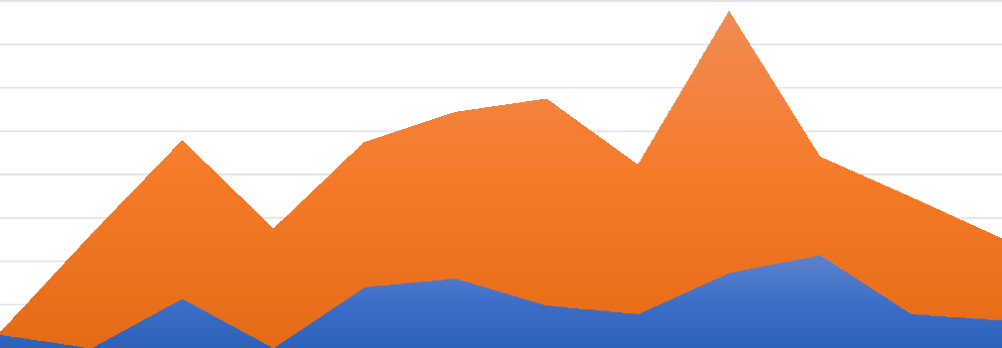
All Product Categories Sales Trend
45000
40000
35000
30000
25000
2020
20000
15000
10000
5000
0
2019
Jan Feb Mar Apr May Jun Jul Aug Sep Oct Nov Dec
Fig. 1: Product Categories Sales Trend

The sales trend for each product category from 2019 to 2020 is displayed in the figure 1. We can observe that sales for every product category in the superstore showed a notable trend in 2020. We can observe a slow increase in sales from the beginning of 2020, followed by a drop in April, possibly because of the onset of COVID. Due to the shift to online learning and work from home, this trend has further changed, and we can observe that September has the highest sales.


Profit by Product Category
60000
$50,250
50000
$40,194
40000

30000

20000

10000
$4,273
0
Furniture
Office Supplies
Technology
Fig.2: Profit By Product Category
From fig.2, we can notice that the largest profit, about $50,250, is made by the technology category, followed by office supplies, which make $40,194. Given that all industries shifted to online platforms during that time, and that there was a need for many tech devices and office supplies, this indicates that technology products are the most profitable, followed by office supplies. This could be a crucial area for investment and expansion. Additionally, the furniture department did not see many sales because of the shift to working remotely or from home. Expanding these categories could therefore lead to increased overall profitability.


Delivery Leadtime
5

4.6

4.2
4.14
3.97
3.98
4.08
Furniture
3.78
3.88
3.93
3.82
3.90
3.8
3.73
Office Supplies
3.55
3.64
Technology
3.4

3
Central
East
South
West
Fig.3: Delivery Leadtime

From fig.3 we can see that the mean delivery leadtimes for the office supplies category is higher across the regions.

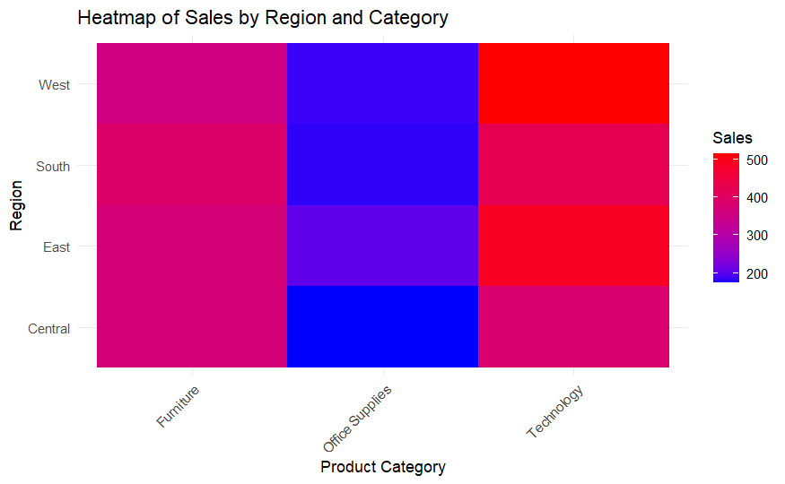
Fig. 4: Heatmap of Sales by Region and Category

From fig.4 we can notice that Technology leads in sales across all regions, particularly in the West. Furniture also performs well in the West but is moderate everywhere else. Office Supplies consistently record the lowest sales, with weak performance in the Central and South regions. This suggests a need for targeted strategies to boost sales in underperforming regions and categories. (Appendix 1)

5.Statistical Analysis

1.Two Sample T-Test (Year Wise Sales Trend)
Objective: The goal of this analysis is to compare the year wise (2019-2020) sales trend across categories and show that the year 2020 had higher sales-(fig.2).
Null Hypothesis (H0): The difference between the population mean of 2020 and 2019 is equal to zero(fig.4)
Alternate Hypothesis (Ha): The population mean of 2020 is higher than the population mean of 2019(fig.4)

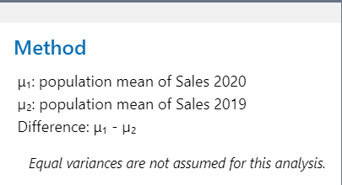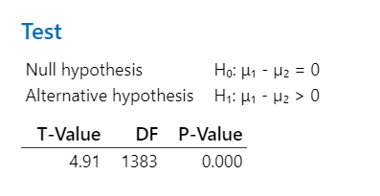
Fig.5: Hypothesis Test

The p-value associated with the test shows us it is zero. This implies us that the difference between the means cannot be equal to zero and hence, we can reject the null hypothesis and there is significant difference in the population mean between the years 2020 and 2019. We conclude that the alternative hypothesis is true showing that the year 2020 had more sales.
Confidence Intervals: The 95% confidence interval for the mean difference is (61.8,124.2). (Fig.5), (Fig.6)

Difference | 95% Lower Bound  for Difference
93.0 | 61.8

Difference | 95% Upper Bound  for Difference
93.0 | 124.2

Fig.6: Confidence Interval

Thus, we can be 95% confident that the population mean sales difference of the years 2020 and 2019 falls within this range.

This analysis provides important insights into the reliability and accuracy of the sales between the years as there appears to be a consistent difference between them.

2. ANOVA Analysis (Category wise Sales)
We have performed ANOVA analysis using Minitab on the range of sales for the different categories.
Our Factor is sales with 3 levels.
Null Hypothesis: All means are equal.
Alternative Hypothesis: Not all means are equal.
We get the P value as 0.000, and since it is lesser than the significance level of 0.05, we reject our null hypothesis. (Fig.7)

Factor | N | Mean | StDev | 95% CI
technology | 519 | 96.5 | 501.0 | (70.6, 122.4)
furniture | 519 | 9.54 | 125.20 | (-16.34, 35.43)
o.s. | 519 | 16.39 | 66.80 | (-9.50, 42.27)
Analysis of Variance Means

Source | DF | Adj SS | Adj MS | F-Value | P-Value
Factor | 2 | 2425083 | 1212542 | 13.42 | 0.000
Error | 1554 | 140443653 | 90376
Total | 1556 | 142868737

Fig.7: Analysis of Variance and Means
This analysis can serve as a basis and tactical choice-making. It may be necessary to implement focused sales improvement methods in departments that have substantial sales variability or continuously poor sales. Tailored sales techniques can be achieved by comprehending the causes of departmental performance variances. For example, a department that has statistically lower sales than the others may benefit from more marketing initiatives or changes to the products it chooses.

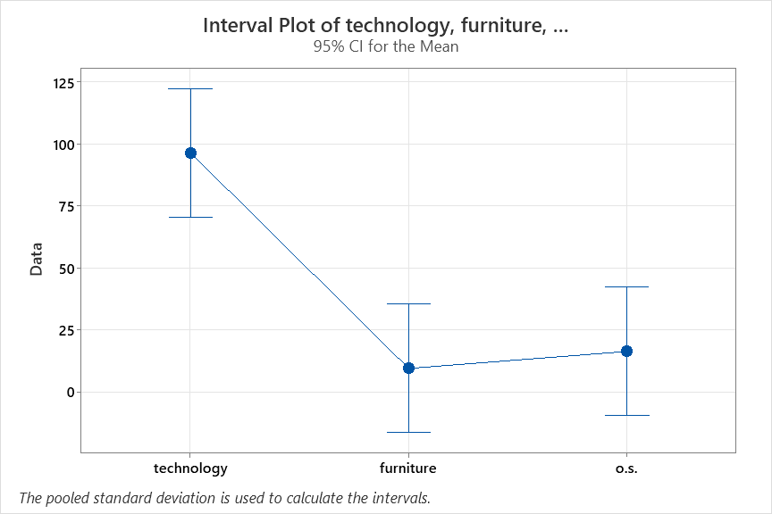
Fig.8 Interval Plot of Technology, Furniture and Office Supplies
Interval Length: The length of the confidence interval for each department reflects the variability in its sales figures. A shorter interval indicates more consistent sales, while a longer interval suggests higher variability. In this case, the technology department has a noticeably longer confidence interval, implying potentially higher sales variability compared to other departments. (Fig.8)
Spread of Confidence Intervals: The horizontal spread of the confidence intervals represents the differences in average sales across departments. A wider spread suggests larger differences in average sales, while a tighter grouping indicates more similar average sales.
Fisher Pairwise Comparisons
Grouping Information Using the Fisher LSD Method and 95% Confidence
Factor | N | Mean | Grouping
technology | 519 | 96.5 | A
O. S | 519 | 16.39 |  | B
furniture | 519 | 9.54 |  | B
Fig 9: Grouping by Sales Performance
The departments are grouped into two categories based on their average sales:
- The highest-selling department is Technology (A). (Fig.9)
- Office supplies (B) and Health and Furniture (B) form the second group with somewhat lower average sales but are not statistically different from each other based on the non-overlapping confidence intervals. (Fig.9)
This grouping allows for identifying top-performing departments to maintain successful strategies while highlighting potential areas for improvement among the lower-performing groups through targeted sales initiatives.
3.ANOVA Analysis (Leadtime Across Regions) We have performed ANOVA analysis using Minitab on Leadtime across different regions. Our Factor is lead time with 4 levels. Null Hypothesis: All means are equal Alternative Hypothesis: All means are equal We get the P value as 0.328, and since it is greater than the significance level of 0.05, we fail to reject our null hypothesis.
Means
Factor | N | Mean | StDev | 95% CI
Lead Time (Days) | 658 | 4.0030 | 1.7560 | (3.8678, 4.1382)
Lead Time (Days)_1 | 756 | 3.8730 | 1.7415 | (3.7469, 3.9991)
Lead Time (Days)_2 | 456 | 3.8531 | 1.6898 | (3.6907, 4.0155)
Lead Time (Days)_3 | 981 | 3.9776 | 1.8327 | (3.8668, 4.0883)

Fig.10: Means

Grouping Information Using the Fisher LSD Method and 95% Confidence
Factor | N |  | Mean |  | Grouping
Lead Time (Days) |  | 658 |  | 4.0030 | A
Lead Time (Days)_3 |  | 981 |  | 3.9776 | A
Lead Time (Days)_1 |  | 756 |  | 3.8730 | A
Lead Time (Days)_2 |  | 456 |  | 3.8531 | A
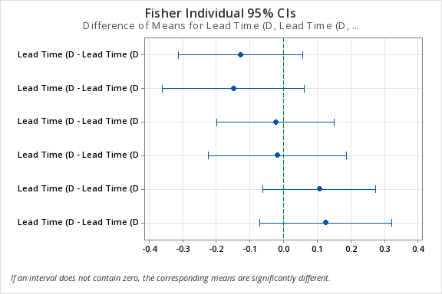
Fig.11: Fisher Individual 95% CIs

The Fisher’s Individual 95% Confidence Intervals group all regions (Central, East, South, and West) into a single category, as their confidence intervals overlap (Fig.11). This supports the ANOVA result, showing no significant difference in mean lead times across the regions.

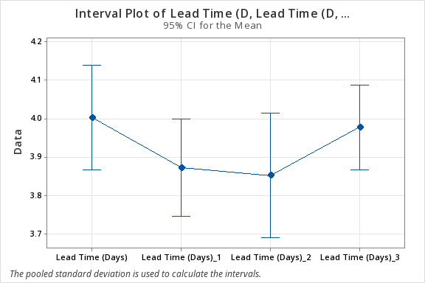
Fig.12: Interval Plot of Lead Time Region wise

The interval plot for lead time across regions shows the mean lead time for each region along with its confidence intervals. The plot indicates overlapping confidence intervals for all regions, suggesting no significant differences in mean lead times. This observation aligns with the ANOVA results, which showed no statistically significant variation in lead times across regions. The mean lead times for all regions are relatively close, further supporting the conclusion that regional differences do not play a substantial role in lead time variability.
4.ANOVA Analysis (Leadtime Per Category) We have performed ANOVA analysis using Minitab on Leadtime per category. Our Factor is lead time with 3 levels. Null Hypothesis: All means are equal Alternative Hypothesis: All means are equal We get the P value as 0.002, and since it is lesser than the significance level of 0.01, we reject our null hypothesis.

Means Analysis of Variance

Factor | N | Mean | StDev | 99% CI
Lead Time (Days)-Tech | 523 | 3.7973 | 1.8479 | (3.5983, 3.9963)
Lead Time (Days)-office supplies | 1744 | 4.0275 | 1.7465 | (3.9185, 4.1365)
Lead Time (Days)-furniture | 584 | 3.7860 | 1.7475 | (3.5976, 3.9743)
Source | DF | Adj SS | Adj MS | F-Value | P-Value
Factor | 2 | 37.81 | 18.907 | 6.06 | 0.002
Error | 2848 | 8879.44 | 3.118
Total | 2850 | 8917.25

Fig.13: Means and Analysis of Variance

Grouping Information Using the Fisher LSD Method and 95% Confidence
Factor | N | Mean | Grouping
Lead Time (Days)-office supplies | 1744 | 4.0275 | A
Lead Time (Days)-Tech | 523 | 3.7973 |  | B
Lead Time (Days)-furniture | 584 | 3.7860 |  | B

Fig. 14: Grouping Information

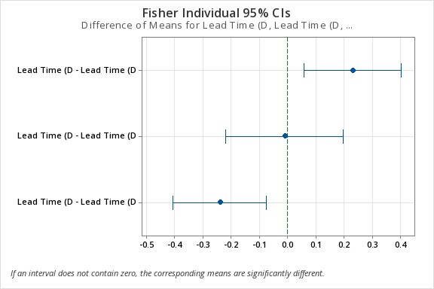
Fig.15: Fisher Individual 95% CI

The Fisher’s Individual 95% Confidence Intervals group Office Supplies into a separate category (Group A) due to its significantly higher mean lead time. Technology and Furniture are grouped together (Group B), indicating no significant difference between their mean lead times. This confirms the ANOVA result, highlighting Office Supplies as having distinctly longer lead times. (Fig.14)

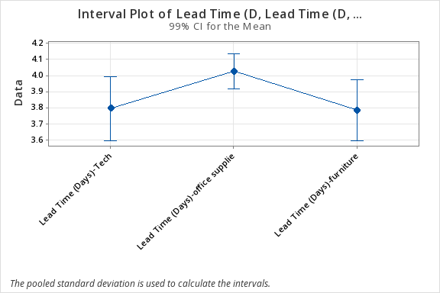

Fig.16: Interval Plot of Lead Time per Category

The fig.16 shows interval plot for lead times by category. The plot indicates that Office Supplies have a higher mean lead time compared to Technology and Furniture. The confidence interval for Office Supplies does not overlap with the intervals for the other two categories, indicating a significant difference. However, Technology and Furniture show overlapping confidence intervals, suggesting no significant difference between their mean lead times.

6.Results
The two sample T-test for concludes that we reject the null hypothesis as the p-value is 0 which is less than the significant level of 0.05 with the confidence level of 95%. Thus, it shows us that the yearly sales of 2020 are higher.

From the ANOVA analysis for category wise profit, we conclude that the technology with highest mean 96.5 is the highest selling category.

The ANOVA analysis for lead-time across regions are almost the same and are grouped together and thus, from our fourth statistical test analysing the lead-time for various product categories we can see that the product category office supplies is grouped separately and has the highest mean 4.02.

7.Conclusion
After analysing the sales data from 2019 and 2020, we observe that 2020 recorded the highest number of sales, reflecting an increase in demand during that period. This could be attributed to various factors, including changes in consumer behaviour influenced by external conditions such as the COVID-19 pandemic, which may have driven customers to purchase more, particularly through online platforms. Furthermore, the analysis reveals that the technology category emerged as the most profitable, contributing significantly to the overall revenue. This suggests that there was a higher demand for technology-related products, possibly driven by the increased reliance on remote work, digital communication, and home office setups during 2020. The profitability of this category highlights the superstore’s strong performance in catering to the growing need for tech products. With respect to lead time (the time between order placement and delivery), our findings indicate that lead times were consistent across regions, meaning that geographic location did not significantly influence how long it took for products to reach customers. However, we observed significant variations in lead time when comparing different product categories. Among the four categories analysed—technology, furniture, office supplies, and others—office supplies had the highest lead time.

8. Strengths And Limitations
1.Key trends, like the year with the highest sales and the most profitable product category, are successfully identified by the project. By concentrating on these elements, we could provide practical advice for business strategy, such as highlighting product categories with strong performance (like technology) to increase future profitability.
2. Hypothesis testing is incorporated into the project to guarantee the statistical validity of the conclusions reached.
3.Small Timeframe: Since the dataset only covers two years (2019 and 2020), it provides a limited view of market conditions and trends. This may not be sufficient for identifying long-term patterns, seasonality, or year-over-year comparisons that extend beyond the available timeframe.
4.No Customer Segmentation: Individual-level information like customer age, gender, income, and location is not included in the dataset. Thus, we cannot conduct customer segmentation without this data, which would enable a more focused examination of buying patterns.
9.Proposed Next Steps
1. Predictive Sales Forecasting
- Once a more extensive dataset is available, we can apply machine learning models to predict future sales trends.
- In future iterations, we can enrich the analysis by including external variables like economic indicators (GDP, inflation rates), competitor pricing, or marketing spend to predict how these factors influence sales and customer demand.
2. Improve Inventory Optimization and Supply Chain Efficiency
- Expand the scope of our analysis to include an analysis of the superstore’s supply chain. We can use the sales and demand data to optimize inventory levels, reduce stockouts, and minimize overstock situations.
- Future work could also focus on analysing warehouse operations and distribution processes to improve efficiency, reduce costs, and ensure timely delivery of products to customers.
3. Evaluate the Impact of Promotions and Discounts
- Future work could analyse the impact of promotions, discounts, and loyalty programs on sales performance. By evaluating which types of promotions yield the highest returns, the superstore can design more effective marketing campaigns to increase sales while maintaining profitability.

10.Collaboration

Team Member | Contributions | Percentage | Signature*
Advait Jigarbhai Naik | Statistical Analysis-ANOVA Test (Category Wise Profit) and Interpretations | 16.66 | 
Ajinkya Vitthalrao Jadhav | Data Visualization-Heatmap and Interpretations, Two Sample T-Test | 16.66 | 
Bhumika Channakeshava | Final Presentation, report compilation and formatting | 16.66
Rushil Vijayan | Created Insights and Interpretations from statistical analysis, derived results, and conclusions. Final report and formatting | 16.66 | 
Shivendra Chandrashekhar Jagtap | Created Statistical analysis using Excel for data visualization and statistical analysis (Two sample T-test) | 16.66 | 
Saloni Vivek Tanpure | Statistical analysis-ANOVA Test for lead-time- region wise and category and provided with related conclusions and results  Data cleaning | 16.66 | 

Copyright
We the team members,

Advait Jigarbhai Naik Rushil Vijayan
Ajinkya Vitthalrao Jadhav Shivendra Chandrashekhar Jagtap
Bhumika Channakeshava Saloni Vivek Tanpure

hereby grant the Mechanical and Industrial Engineering (MIE) Department of Northeastern University, Prof. Rehab Ali, unlimited non-exclusive license to use, modify or distribute this report and the corresponding Executive Summary and Poster. We also hereby agree that the video or other digital recordings of our Oral Presentations and Demonstrations are the full property of the MIE Department.
The publication of this report does not constitute approval by Northeastern University, the MIE Department or its faculty members of the findings or conclusions contained herein. It is published for the exchange and stimulation of ideas.

Appendix
1.
{r}
heatmap_data <- reshape2::dcast(aggregated_data, Region ~ Product Category, value.var = "Sales")
```
```{r}
ggplot(aggregated_data, aes(x = Category, y = Region, fill = Sales)) +
geom_tile() +
scale_fill_gradient(low = "blue", high = "red", na.value = "white") +
labs(title = "Heatmap of Sales by Region and Category",
x = "Product Category", y = "Region", fill = "Sales") +
theme_minimal() +
theme(axis.text.x = element_text(angle = 45, hjust = 1))
```
```{r}
install.packages("tinytex")
tinytex::install_tinytex()

```{r}

2. All the comments from the project progress report were addressed and changed in the final report.

Bibliography
- Superstore: Data Visualization
https://www.kaggle.com/code/aaronlikevis/superstore-data-visualization-with-power-bi/input

[2] Cleaned Dataset
https://drive.google.com/drive/folders/17m-qQutOdM3ffb7KCWIhon4HByzCLKNq?usp=drive_link

